A Creative Web-Based Learning
Application Integrating Notes, Quizzes, and Cognitive Skill Games

Amina Zaiba
Department of Computer Science, Bio-intelligence Lab
Presidency University
Bangalore, India
aminazaiba2102@gmail.com

Srushti
Department of Computer Science, Bio-intelligence Lab
Presidency University
Bangalore, India
srushtishivakumar8@gmail.com
Kalpana K Harish
Department of Computer Science, Bio-intelligence Lab
Presidency University
Bangalore, India
kalpanaharish1983@gmail.com

.
Amreen Kowsar
Department of Computer Science, Bio-intelligence Lab
Presidency University
Bangalore, India
amreenkowsar2004@gmail.com

Abstract-Technology has transformed the way students learn, work together, and evaluate their understanding in the current education system. Traditional methods of teaching in the classroom, although helpful, are not flexible and do not fully engage students who are accustomed to interactive and technology-driven environments. Web-based learning platforms have been found to be an answer through their scalability, accessibility, and interaction potential for education. However, most of the existing platforms only handle either content presentation or testing, little combining cognitive skill development and gamification methodologies.
In this research, an innovative web-based learning application that brings together three integral components—notes, quizzes, and cognitive skill games—is introduced under a combined platform.

Keywords-Web-based learning, educational games, quizzes, cognitive skills, student dashboard, teacher dashboard, gamification

The proposed system is designed to support both students and teachers with customized dashboards and role-based features. Students can register securely, see collaborative notes, participate in time-sensitive quizzes, and unlock cognitive ability games based on quiz performance. Teachers, on the other hand, can register to post lecture notes in PDF or text format, create quizzes with auto-grading, and monitor student progress in real time.

This two-dashboard approach not only facilitates teacher-student interaction but also ensures a structured and engaging learning experience.
The deployment is carried out using modern web technologies, including HTML5, CSS3, JavaScript . Responsive design is utilized to enable the application to be accessed on any device. Pilot deployment to a test population of students and faculty showed increased interaction, improved knowledge retention, and higher motivation from gamification functionality.

I. INTRODUCTION

The field of education has undergone a remarkable transformation over the past two decades, with technology playing a central role in reshaping teaching and learning methodologies. The evolution from chalkboards to digital projectors, and from physical textbooks to interactive e-learning platforms, reflects the increasing integration of information and communication technologies (ICT) into education. Among these innovations, Web-Based Learning (WBL) has been one of the most influential innovations, enabling students to study anytime and anywhere and allowing educators to create dynamic and interactive learning environments.
Learning in the knowledge economy is no longer contained within the four walls of a classroom. The learners require more than content-delivery vehicles; they require vehicles that enable active engagement, self-awareness, and cognitive growth. Traditional pedagogies, as significant as they are, cannot meet such evolving demands due to their inability to offer interactivity, flexibility, and dependence on strict timing. WBL systems, however, provide a learning environment that is student-focused, with students being able to study at their own pace, virtually collaborate with fellow students, and receive instantaneous feedback from instructors or computer systems.
Despite all the benefits of WBL, the main flaw of the majority of the existing systems is that there is no coordination between content delivery, testing and assessment, and skill building. For instance, there are websites that provide course materials only, whereas others provide administering quizzes or exams online. Few systems manage to bring these elements together into an overall system that not just facilitates learning but also develops higher-order intellectual skills like critical thinking, problem-solving, and decision-making. Moreover, while gamification has been found to be an effective motivational tool, its implementation in web-based learning environments remains superficial, based on the level of badges or points rather than on substantial, skill-developing activities.

II. RELATED WORK

Web-Based Learning (WBL) systems have developed considerably in the last ten years, and there are many tools that intend to improve access, interactivity, and engagement of learners. Indeed, initial WBL took the form of course materials and simple assessment features provided on-line through systems like Moodle and Blackboard. These systems represented an early shift from face-to-face teaching to the web, focusing much on content management rather than on cognitive skills development or adaptive learning mechanism.

Recent developments in e-learning have evolved providing systems with multimedia enriched material, evaluation (automated grading) and cooperation tools. Platforms for learning management (LMS) such as Google Classroom and Canvas have provided means of facilitating instructor–student engagement with features for simplified assignment delivery, real-time commenting and open communication. But these systems generally structure instructional content, assessment and mechanisms for student engagement as isolated modules which can constrain their ability to function as an integrated learning framework.

Gamification has been used as a strategy for learners motivation, with several elements of game-like structures, such as badges, progress bars, leaderboards and rewards. It has been proved by research that the gamified learning environments enhance students involvement and retention. However, a great proportion of current gamified systems are concentrated on rewards with little cognitive effort and fail t integrate relevant games that could include significant lack of either critical thinking, memory and problem solving. Platforms such as Kahoot! and Quizizz, offer interactive quizzes and competitive aspects, however they do not include formal note-taking tools or cognitive skill games that are connected to the learner performances.

Studies on cognitive training techniques have shown that playing memory games, brain teasers or problem solving activities have direct benefits in learning. Nevertheless, such tools are frequently implemented as standalone applications and seldom integrated within educational learning environments. This discrepancy between traditional learning content, assessment tools, and cognitive development apps reflects a lack of integrated systems that combine these elements together.
Accordingly, although a significant enhancement has been given for development of WBL infra-structures and environment, existing literature and systems have shown that there is still the lack of integration in between contents delivery, assessment, learning support strategies (e.g., care of a student with special needs), knowledge upgrades and cognitive skills developments. The gap points to the necessity of a single platform that fuses lecture notes, auto-graded quizzes and cognitive skill matching games in a single integrated gamified educational ecosystem – exactly what the proposed system tries to achieve.

III. SYSTEM ARCHITECTURE

A. Architecture

Front-End: HTML5, CSS3, JavaScript design for responsiveness. It possesses separate dashboards for teachers and students, such as role-based features such as quiz attempts, notes accessibility, game un-locking, and performance tracking.
File Storage: Notes and other files uploaded are stored on the server, with references stored in local storage
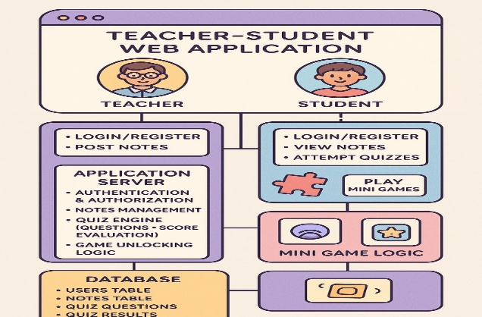
Figure 1: System Level Architecture

The figure 1 shows the high level architectural diagram about web application which are built for teacher, student both in mind. The system is composed of three primary entities: client side UIs, the application server and the database.
A Teacher and a Student: In the figure, two different types of roles come to life. Teachers have the ability to login, register and write notes. For students, however, the site offers logging in, signing up, seeing notes and doing quizzes while playing mini-games. This separation of responsibilities highlights

B. User Registration Module

The registration system provides role-based registration flows:
Student Registration: Captures full name, roll number, class, email ID, mobile number, school name, and password. Students are created with individual IDs and receive verification emails.
Teacher Registration: Captures full name, email ID, mobile number, highest qualification, school name, and password. Teachers receive the ability to create, administer, and monitor quizzes, post notes, and see student performance details.

C. Student Dashboard

Student dashboard is instant feedback, interactive, and intuitive. Key features are:
Quiz Access: Students can attempt quizzes within 24 hours of posting. Each quiz is timed (e.g., 10 minutes per quiz) and computer-graded automatically.
Notes Access: Teachers put up notes in text or PDF format, organized by subject and topic.
Performance Tracking: Students can view their scores, progress graphs, and game unlock status.
Game Unlocking System: Brain skill games are unlocked on the basis of quiz performance to retain the users.

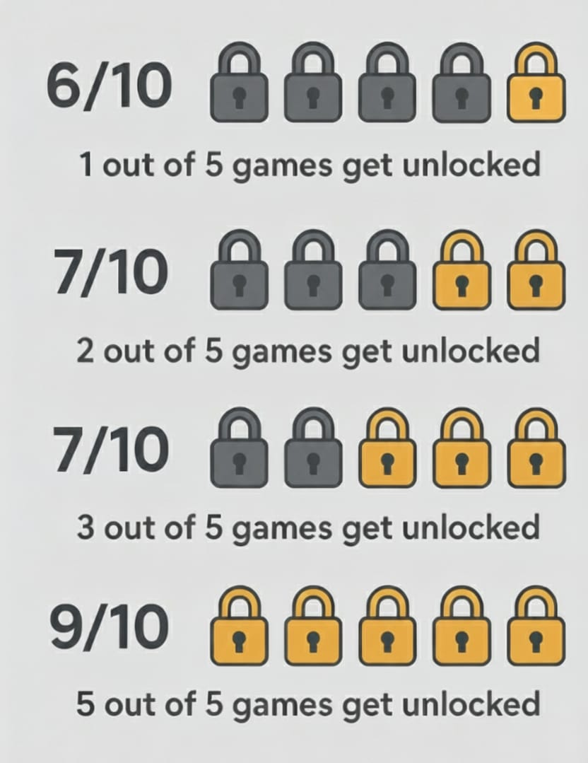
Figure 2: Game Reward System

The figure 2 represents a tiered content unlocking system used to gamify performance data in a way that encourages user engagement by delivering swift feedback. The model takes a performance-shaping measure, in this case a score out of a possible 10, and translates it into a reward-structure. The following threshold levels are defined:
score of 6/10 unlocks one out of five possible games
score of 7/10 unlocks two out of five possible games
score of 8/10 unlocks three out of five possible games
score of 9/10 or higher unlocks all five possible games.
Analysis of the Design
This proposal serves as a basic but effective gamification model. By establishing clear short-term goals, it encourages incremental improvement. It provides users with rewards for scoring over 6/10 based on cumulative performance; hence reinforcing effort before signals encouraging users to reach even greater heights.
A notable feature of the design is the exponential reward curve present toward the top of the model. Between levels of mastery 6, 7 & 8 scores only a single piece of content is unlocked for reaching the next score level. However, when moving from an 8/10 to a 9/10 score users receive access to the final two pieces of content & this is a deliberate design choice. A user may choose to dedicate their time & effort in trying to achieve a high level of mastery & content unlocking over a very considerable time span. However, this curve, when stretched over a longer period, will act as an extremely strong motivator to push toward the pinnacle of mastery & content unlocking & provides users with a true sense of completion in achieving not only unlocking all content but also an indicator of exceptional high performance.

D. Teacher Dashboard

The teacher dashboard provides tools for content creation, management, and tracking
Notes Management: Teachers can upload PDFs and text notes.
Quiz Creation: Teachers can create up to 10 questions per subject per day. Answers remain hidden until assessment.
Performance Monitoring: Student activity, quiz scores, and progress are monitored by teachers.
Communication Tools: Contact information and notifications enable communication with learners.
Teacher Dashboard Design:
Mockup: Visualization of quiz creation, note upload, and student performance analysis.

E. Design Principles

Modularity: All features (quizzes, notes, games) are modular and therefore updatable separately.
Scalability: Support for future growth, including additional games, AI commenting, and analytics.
Usability: Simple interfaces to enable easy use across multiple devices.
Security: In-built authentication, encrypted storage, and safe session management.
Engagement: In-built encouragement and engagement through gamification and performance feedback mechanisms.

IV. IMPLEMENTATION DETAILS

A Overview

The deployment stage focuses on converting the system design into a finished, operational web-based learning system. The system has notes, quizzes, and intellectual ability games implemented with security, ease of use, and scalability guaranteed.

B. Authentication Module

User Registration and Login: Students and teachers register through email and password.
Session Management: Token-based authentication with secure session management ensures access by legitimate personnel.
Role-Based Access Control: Students and teachers possess individual dashboards and access rights.

C. Quiz Engine

Quiz Creation: Teachers can create a maximum of 10 questions per day per subject with masked correct answers.
Time-Limited Attempt: Quizzes are timed at 10 minutes, and the quiz is automatically submitted on timeout.
Automatic Assessment: The system automatically marks answers and updates scores in the database.
Game Unlocking Reasoning: Scores on quizzes determine which cognitive skill games are unlocked for students.

D. Notes Administration Module

File Upload: Teachers upload notes as PDF or text and store them on the server with pointers to the database.
Structure: Notes are structured by subject and topic.
Access Control: Only authorized students have access to the notes.

E. Game Module

Integration: Games for cognitive skills are integrated with the student dashboard.
Progress Tracking: Student progress is monitored and stored in the database.
Gamification Strategy: Games motivate learning and improve concentration, memory, and problem-solving skills.

F. Dashboard UI

Responsive Design: Bootstrap provides device compatibility.
Student Dashboard: Exhibits quizzes, notes, games, and performance graphs.
Teacher Dashboard: Where quizzes can be created, notes can be uploaded, and students' performance can be monitored.

G. Security Implications

Data Encryption: Passwords and data are encrypted.
Regular Backups: Avoids any loss of data and system integrity.

H. Technology Stack

Front-End: HTML5, CSS3, JavaScript.
Storage: local storage

V. RESULTS

Student performance and game unlocking sample is described below:

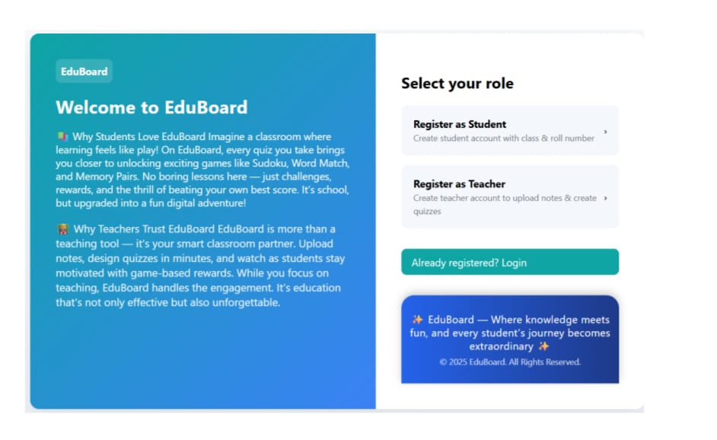
Figure 3: The EduBoard User Interface for Role Selection and Registration

The figure 3 displays the EduBoard web application's user interface. A promotional panel on the left and an interactive panel on the right make up the page's two primary sections. The platform is introduced in the teal-colored panel on the left. It highlights the main attributes and target audiences of EduBoard: For Learners: Games like Sudoku, Word Match, and Memory Pairs are unlocked through quizzes on the platform, which is referred to as a gamified learning environment. Making learning feel more like a "fun digital adventure" as opposed to a chore is the aim. For Teachers: EduBoard is marketed as an intelligent classroom assistant that boosts teacher participation. They can quickly create quizzes and upload notes, and the platform uses game-based learning to keep them motivated.


Figure 4:Multiple-Choice Quiz within EduBoard

This figure 4 showcases a snippet of a multiple-choice quiz interface from the EduBoard app. In the screenshot, you can see five quiz questions, labeled Q1 to Q5, along with their corresponding answer choices.
The design is straightforward and tidy, putting the spotlight on the questions and the answers the student has chosen. It looks like a typical online assessment. For each question, the student has already picked one option, marked by a blue filled circle. Here’s what they selected:
Q1: The answer "1" is chosen.
Q2: The answer "5" is chosen.
Q3: The answer "3" is chosen.
Q4: The answer "3" is chosen.
Q5: This question seems to be a short-answer or fill-in-the-blank type, as the student's response "32ee" is shown right below it.
The figure 4 does a great job of illustrating the quiz-taking feature of the platform, which is a key activity for students before they can earn their gamified rewards. It offers a clear visual representation of how student responses are recorded within the app's assessment module.

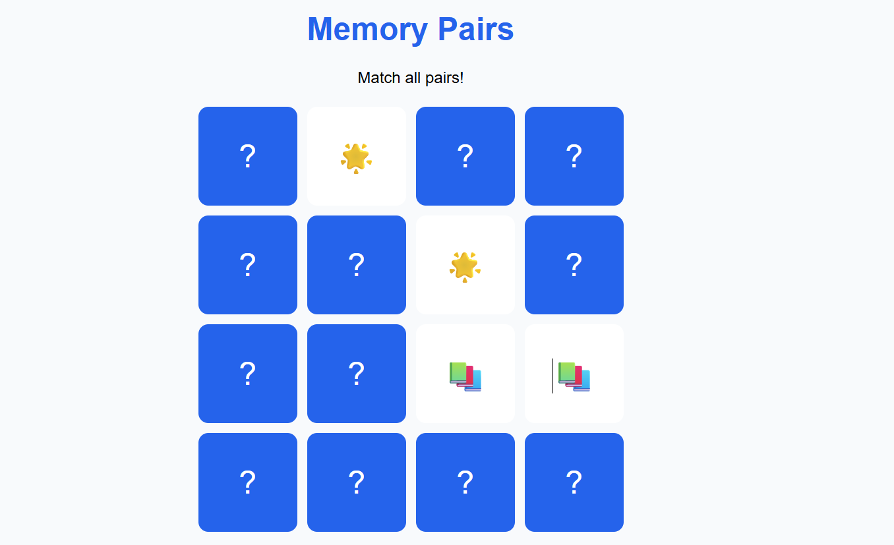

Figure 5: Memory Pairs Game Interface – The EduBoard Mental (Cognitive Skill) memory game.

Memory Pairs game interface of the EduBoard gamified learning plat-form, a cognitive skill–enhancing activity to enhance students’ concentration,pattern recognition, and short-term memory (see Figure 13). The interface is nice and clean with a blue grid of tiles each with a question mark symbol (“?”). on the front. Players turn these tiles over one at a time to reveal hidden icons and then try to find the matching patterns.

At the head it reads “Memory Pairs” large in blue and underneath “Match all pairs!” underneath, serving as a clear prompt. Here, a few tiles have been flipped over to yield matches like gold sundisks and stackable cards in varying colors to reflect successful or possibly ongoing matches. The nonflipped ones still wear their neutral blue, leaving a contrasting visual.
The gameplay is very intuitive and easy to get into for all age group. With playfulness and interactivity, students improve memory and flexibility of mind while achieving the aim of making fun an opportunity for learning on EduBoard. Fig 5 EduBoard uses game based learning to engage the mind, and make study interesting as well as rewarding.

VII. CONCLUSION AND FUTURE WORK

A. Conclusion

This paper proposes a comprehensive web-based learning environment with notes, quizzes, and cognitive ability games to facilitate student interaction, effectiveness in learning, and teacher-student communication. The principal achievements of the system include:
Secure Registration and Role-Based Dashboards: Student and teacher have their individual dashboards with appropriate authorizations.
Time-Bound Quizzes and Automated Assessment: Instant feedback for quizzes is offered to students, and their performance is monitored in real time.
Centralized Notes Administration: Various note formats can be uploaded by teachers and shared with students depending on their role.
Gamification and Cognitive Development: Students access learning games from the performance in quizzes, promoting motivation and cognitive development.
Positive Impact on Engagement: Pilot deployment indicates greater student engagement and improved knowledge retention.
The study demonstrates how having delivery of content, testing, and cognitive skill acquisition all on one platform results in a superior learning experience compared to traditional methods or ad-hoc web-based tools.

B. Future Work

The platform sets the stage for future research and development. Potential areas of future development include:
AI-Based Adaptive Feedback: Integrating machine learning algorithms to deliver individualized feedback, targeted interventions, and adaptive quizzes depending on student performance.
Multimodal Engagement Detection: Implementing facial recognition, activity monitoring, and other sensors to detect student engagement in real-time, enabling timely supportive interventions.
Large-Scale Deployment: Deploying the system at bigger educational institutions to validate scalability, reliability, and effectiveness.
Cognitive Skill Games with Increased Scope: Developing more games that cater to multiple cognitive skills, such as reasoning, memory, attention, and critical thinking.
Learning Analytics Dashboard: Addition of advanced analytics, trend reporting, and predictive capabilities to the teacher dashboard for data-driven decision-making.
Mobile App Development: Creating a mobile app variant to broaden accessibility and flexibility to teachers and students.
Cumulatively, these future enhancements will increase the system's capacity to deliver an holistic, interactive, and responsive learning experience to augment educational outcomes across different learning environments.

REFERENCES

[1] Cook, D.A., “Web-based learning: pros, cons and controversies,” Clin. Med., vol. 7, no. 1, pp. 37–42, 2007. https://doi.org/10.7861/clinmedicine.7-1-37

[2] Vlachopoulos, D. & Makri, A., “The effect of games and simulations on higher education: a systematic literature review,” Int. J. Educ. Technol. High. Educ., vol. 14, no. 22, 2017. https://doi.org/10.1186/s41239-017-0062-1

[3] Bokolo, A.J. et al., “Blended Learning Adoption and Implementation in Higher Education: A Theoretical and Systematic Review,” Educ. Inf. Technol., 2020. https://doi.org/10.1007/s10758-020-09477-z

[4] Kefalis, A., Drigas, A., “Web Based and Online Applications in STEM Education,” Int. J. Emerg. Pract.2019. https://doi.org/10.3991/ijep.v9i4.10691

[5] Drigas, A., Karyotaki, M., “Online and other ICT-based Training Tools for Problem-solving Skills,” Int. J. Emerg. Technol. Learn., 2016. https://doi.org/10.3991/ijet.v11i06.5340

[6] Karyotaki, M., Drigas, A., “Online and other ICT Applications for Cognitive Training and Assessment,” Int. J. Online Educ., 2015. https://doi.org/10.3991/ijoe.v11i2.4360

[7] Kremer, G., Mehta, R., “Interactive Problem Solving For Mechanical Engineering On The World Wide Web,” 2020. https://doi.org/10.18260/1-2--9443

[8] Sun, J.C.-Y. et al., “Peer Assessment Enhances Student Learning,” PLoS ONE, 2015. https://doi.org/10.1371/journal.pone.0143177

[9] Cho, K., Cosimini, M., Espinoza, J., “Podcasting in medical education: a review of the literature,” 2017. https://doi.org/10.3946/kjme.2017.69

[10] McLoughlin, C., Lee, M.J.W., “Personalised and self regulated learning in the Web 2.0 era,” 2010. https://doi.org/10.14742/ajet.1100

[11] Dichev, C., Dicheva, D., “Gamifying education: what is known, what is believed and what remains uncertain: a critical review,” 2017. https://doi.org/10.1186/s41239-017-0042-5

[12] Cocea, M., Weibelzahl, S., “Disengagement Detection in Online Learning: Validation Studies and,Perspectives,”2010. https://doi.org/10.1109/tlt.2010.14

[13] Dewan, M., Murshed, S., Lin, J., “Engagement detection in online learning: a review,” 2019. https://doi.org/10.1186/s40561-018-0080-z

[14] Hooda, S. et al., “Artificial Intelligence for Assessment and Feedback to Enhance Student Success in Higher Education,” 2022. https://doi.org/10.1155/2022/5215722

[15] Youhasan, S. et al., “Developing and evaluating an educational web-based tool for health professions education: the Flipped Classroom Navigator,” 2022. https://doi.org/10.1186/s12909-022-03647-6

[16] Ibrahim, R. et al., “Students Perceptions of Using Educational Games to Learn Introductory Programming,” 2010. https://doi.org/10.5539/cis.v4n1p205

